8. LAMINAR FLOW
LAMINAR FLOW: A flow in which layers (Laminas) of fluid slides over one another with relative velocities by the virtue of viscous forces.
CHARACTERISTICS OF LAMINAR FLOW:  - $Re$ & $KE$ of low is relatively lower.  - No intermixing of fluid particles between the layers.  - No random fluctuation of velocity of fluid particles with respect time.  - Newtons law of viscosity is enough to calculate shear stress.  - Flow is rotational.  - Surface roughness of pipe does not affect losses in laminar flow. | EXAMPLES OF LAMINAR FLOW:  - Flow past dust particles settling of impurities.  - Capillary flow in soil.  - Flow of blood in veins.  - Flow through pipe.  - Flow between parallel plates.  - Open channel flow:$Re≤500$  - Flow past sphere (stokes law): $Re≤1$

LAMINAR FLOW THROUGH PIPE: $Re≤2000$  - Local Velocity:  Here, $y=R-r⇒dy=-dr$  $$τ=μ\frac{du}{dy}=μ\left(\frac{-du}{dr}\right)=\left(\frac{-dP}{dx}\right)\frac{r}{2}⇒du=\frac{1}{2μ}\left(\frac{dP}{dx}\right)rdr \left(From Previous Chp.\right)$$ |  |  | 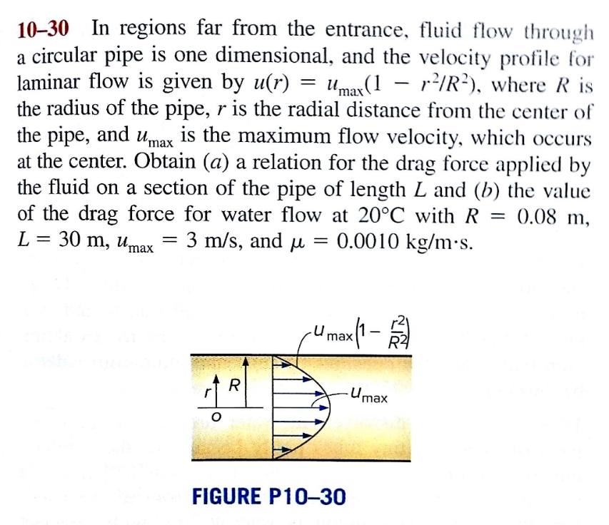
$$u=\frac{1}{4μ}\left(\frac{dP}{dx}\right)r^{2}+C$$ | $$C=\frac{1}{4μ}\left(\frac{-dP}{dx}\right)R^{2}(∵BC @r=R, u=0)$$ | $$u=\frac{1}{4μ}\left(\frac{-dP}{dx}\right)(R^{2}-r^{2})$$
This is equation of local velocity in laminar flow through pipes.

OBSERVATIONS:  - $u=f\left(r\right)$.  - Local Velocity decreases parabolically with respect to “r”.  - Maximum Local Velocity is attaining at centreline. $r=0$ |  | $$u_{max}=\frac{1}{4μ}\left(\frac{-dP}{dx}\right)R^{2}$$  $$∴\frac{u}{u_{max}}=1-\frac{r^{2}}{R^{2}}$$
- Discharge:
$$dQ=udA=u_{max}\left(1-\frac{r^{2}}{R^{2}}\right)2πrdr$$ | $$Q=πR^{2}\frac{u_{max}}{2}$$
Average velocity: $V_{avg.}=Q/A$ | $$V_{avg.}={u_{max}}/2$$
NOTE: At $u=V_{avg.}$ (Local Velocity = Avg. Velocity)$,R=\sqrt{2}r$.
- Pressure Drop Equation (Hagen-Poiseuille Equation):
$$V_{avg.}=\frac{u_{max}}{2}=\frac{1}{8μ}\left(\frac{-dP}{dx}\right)R^{2}=\frac{1}{8μ}\left(\frac{∆P}{L}\right)R^{2}$$ | $$∵\frac{-dP}{dx}=\frac{∆P}{L}$$ | $$∆P=\frac{32μV_{avg.}L}{D^{2}}=\frac{128μQL}{πD^{4}}$$

- Head Loss:  $$h=\frac{∆P}{γ}=\frac{32μV_{avg.}L}{γD^{2}}=\frac{128μQL}{γπD^{4}}$$ | - Equation of Power Loss:  $$P=hγQ=\frac{128μQ^{2}L}{πD^{4}}$$
- Fanning’s Friction coefficient$\left(f^{'}\right)$:
$$f^{'}=\frac{τ_{0}}{\left(1/2\right)ρV^{2}}=\frac{16}{Re}$$ | $$∵τ_{0}=\left(\frac{-dP}{dx}\right)\frac{R}{2} \& V_{avg.}=\frac{1}{8μ}\left(\frac{-dP}{dx}\right)R^{2}$$

- Darcy Friction Factor$\left(f\right)$:$f=4f^{'}={64}/{Re}$
SUMMARY
- Local Velocity | - Avg. Velocity $\left(V_{avg.}={u_{max}}/2\right)$ | - Discharge$\left(Q=V_{avg.}A\right)$
- Drop in Pressure$\left({-dP}/{dx}={∆P}/L\right)$ | - Head Loss$\left(h={∆P}/γ\right)$ | - Power Loss $\left(P=hγQ\right)$
- $f^{'}={16}/{Re}$ | - $f=4f^{'}={64}/{Re}$
NOTE: If pipe is inclined, Replace Pressure with piezometric pressure. $P=P^{*}$& $x$ is axis of flow.

FLOW BETWEEN TWO FIXED PARALLEL PLATES: $Re≤1000$
From continuity equation, $V_{1}=V_{2}$  From momentum conservation equation,  $$PdyW-\left(P+dP\right)dyW+\left(τ+dτ\right)dxW-τdxW=0$$  $$\frac{dP}{dx}=\frac{dτ}{dy}(Equation Governing The Flow)$$  $$τ=μ\frac{du}{dy}⇒\frac{dτ}{dy}=\frac{dP}{dx}=\frac{d^{2}u}{dy^{2}}$$ |  |  | 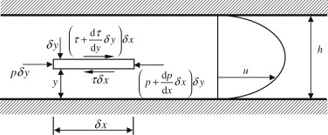
$$u=\frac{1}{2μ}\left(\frac{dP}{dx}\right)y^{2}+C_{1}y+C_{2}$$ | $$C_{1}=\frac{1}{2μ}\left(\frac{-dP}{dx}\right)B\left(\begin{aligned}∵BC@ y=B/2, \\ u=u_{max}⇒{du}/{dy}=0\end{aligned}\right)$$ |  |  | $$C_{2}=0$$  $$(∵BC @ y=0, u=0)$$
$$u=\frac{1}{2μ}\left(-\frac{dP}{dx}\right)\left(By-y^{2}\right)(Parabolic)$$ |  | $$u_{max}=\frac{1}{8μ}\left(-\frac{dP}{dx}\right)B^{2}\left(∵u=u_{max} @y=\frac{B}{2}\right)$$
Discharge:
$$dQ=udA=\frac{1}{2μ}\left(-\frac{dP}{dx}\right)\left(By-y^{2}\right)dyW$$ | $$Q=\frac{1}{12μ}\left(-\frac{dP}{dx}\right)B^{3}W$$
Average velocity: $V_{avg.}=Q/A$ | $$V_{avg.}=\left(2/3\right) u_{max}$$

Pressure Drop:
$$∆P=\frac{12 μV_{avg.}L}{B^{2}}=\frac{12 μQL}{B^{3}W}\left(\begin{aligned}∵From V_{avg.} Formula \\ From Discharge Formula\end{aligned}\right)$$ | $$∵\frac{-dP}{dx}=\frac{∆P}{L}$$

Head Loss:  $$h=\frac{∆P}{γ}=\frac{12 μV_{avg.}L}{γB^{2}}=\frac{12 μQL}{γB^{3}W}$$ |  | Power Loss:  $$P=hγQ=\frac{12 μQ^{2}L}{B^{3}W}$$
Shear Stress:  $$τ=μ\frac{du}{dy}=\left(-\frac{dP}{dx}\right)\left(\frac{B-2y}{2}\right)(Linear Profile)$$ |  | Wall Shear Stress: $τ=τ_{0}@ y=0$  $$τ_{0}=\left(-\frac{dP}{dx}\right)\left(\frac{B}{2}\right)$$
NOTE: Here, $y$ is distance measured from wall not centre.
SUMMARY:
- Local Velocity | - Avg. Velocity $\left[V_{avg.}=\left(2/3\right) u_{max}\right]$ | - Discharge$\left(Q=V_{avg.}A\right)$
- Drop in Pressure$\left({-dP}/{dx}={∆P}/L\right)$ | - Head Loss$\left(h={∆P}/γ\right)$ | - Power Loss $\left(P=hγQ\right)$
- Shear Stress
NOTE: If Plates are inclined, Replace Pressure with piezometric pressure. $P=P^{*}$ & $x$ is axis of flow.
COUETTE FLOW: Laminar Flow Between two parallel plates such that one plate is moving relative to the other.
TYPES OF COUETTE FLOW
$$\frac{dP}{dx}>0(Parabolic)$$ |  | $$\frac{dP}{dx}=0(Linear)$$ | $$\frac{dP}{dx}<0(Parabolic)$$
Backward Couette Flow: Laminar Flow is in the direction opposite to the moving Plate. |  | Simple/ Pure/ Plane Couette Flow | Forward Couette Flow: Laminar Flow is in the direction of the moving Plate.
$$u=\frac{1}{2μ}\left(\frac{dP}{dx}\right)y^{2}+C_{1}y+C_{2}$$ |  | $$\frac{u}{U}=\frac{y}{B}$$ | $$u=\frac{1}{2μ}\left(\frac{dP}{dx}\right)y^{2}+C_{1}y+C_{2}$$
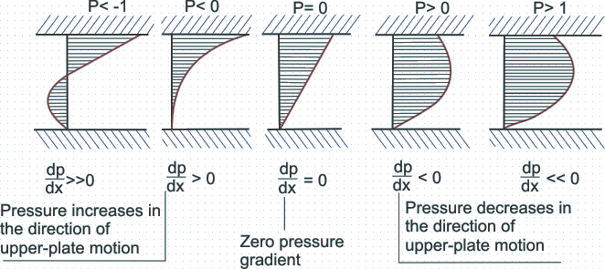
$$V_{CF}=V_{Simple Flow}+V_{Flow Btw. 2fixed plate}$$ | $$Q_{CF}=Q_{Simple Flow}+Q_{Flow Btw. 2fixed plate}$$
$$V_{CF}=U\left(\frac{y}{B}\right)+\frac{1}{2μ}\left(-\frac{dP}{dx}\right)\left(By-y^{2}\right)$$ | $$Q_{CF}=\frac{1}{2}UBW+\frac{1}{12μ}\left(-\frac{dP}{dx}\right)B^{3}W$$ |  |  | $$V_{avg.}=\frac{Q}{A}=\frac{Q}{WB}$$
$$τ_{CF}=τ_{Simple Flow}+τ_{Flow Btw. 2fixed plate}$$ | $$τ_{CF}=μ\frac{dV_{CF}}{dy}=μ\left(\frac{U}{B}\right)+\left(-\frac{dP}{dx}\right)\left(\frac{B-2y}{2}\right)$$
$$u_{max}={\left.u\right|}_{\frac{du}{dy}=0}$$

